PIZZA SALES SQL QUERIES
A. KPI’s
1. Total Revenue:
SELECT SUM(total_price) AS Total_Revenue FROM pizza_sales;
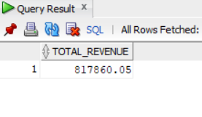
2. Average Order Value
SELECT (SUM(total_price) / COUNT(DISTINCT order_id)) AS Avg_order_Value FROM pizza_sales
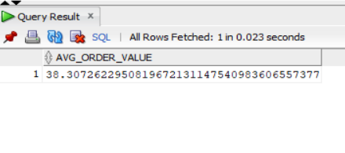
3. Total Pizzas Sold
SELECT SUM(quantity) AS Total_pizza_sold FROM pizza_sales
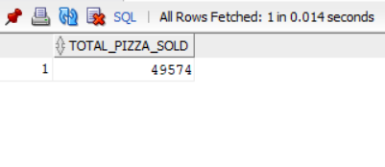
4. Total Orders
SELECT COUNT(DISTINCT order_id) AS Total_Orders FROM pizza_sales
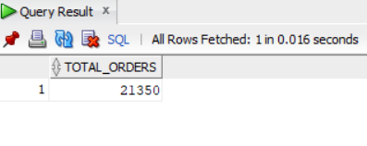
5. Average Pizzas Per Order
SELECT CAST(CAST(SUM(quantity) AS DECIMAL(10,2)) /
CAST(COUNT(DISTINCT order_id) AS DECIMAL(10,2)) AS DECIMAL(10,2))
AS Avg_Pizzas_per_order
FROM pizza_sales
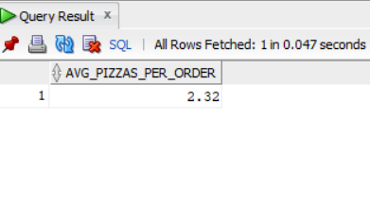
B. Daily Trend for Total Orders
SELECT DATENAME(DW, order_date) AS order_day, COUNT(DISTINCT order_id) AS total_orders
FROM pizza_sales
GROUP BY DATENAME(DW, order_date)
Output:
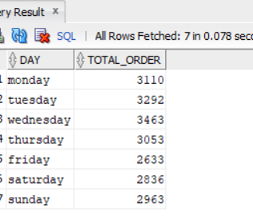
C. Monthly Trend for Orders
select DATENAME(MONTH, order_date) as Month_Name, COUNT(DISTINCT order_id) as Total_Orders
from pizza_sales
GROUP BY DATENAME(MONTH, order_date)Output
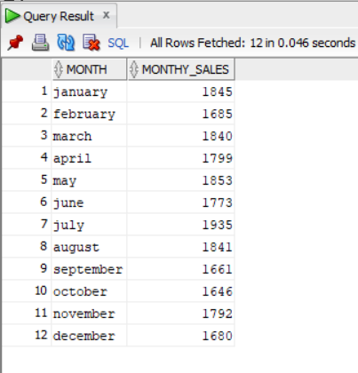

D. % of Sales by Pizza Category
SELECT pizza_category, CAST(SUM(total_price) AS DECIMAL(10,2)) as total_revenue,
CAST(SUM(total_price) * 100 / (SELECT SUM(total_price) from pizza_sales) AS DECIMAL(10,2)) AS PCT
FROM pizza_sales
GROUP BY pizza_category
Output
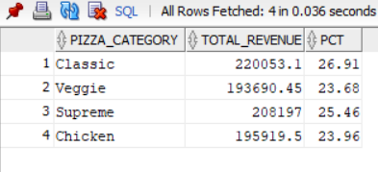
E. % of Sales by Pizza Size
SELECT pizza_size, CAST(SUM(total_price) AS DECIMAL(10,2)) as total_revenue,
CAST(SUM(total_price) * 100 / (SELECT SUM(total_price) from pizza_sales) AS DECIMAL(10,2)) AS PCT
FROM pizza_sales
GROUP BY pizza_size
ORDER BY pizza_size
Output
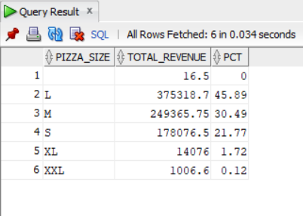

F. Total Pizzas Sold by Pizza Category
SELECT pizza_category, SUM(quantity) AS total_quantity_sold
FROM pizza_sales
GROUP BY pizza_category
ORDER BY total_quantity_sold DESC;
Output
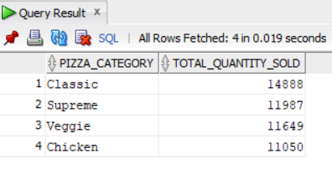
G. Top 5 Pizzas by Revenue
SELECT Top 5 pizza_name, SUM(total_price) AS Total_Revenue
FROM pizza_sales
GROUP BY pizza_name
ORDER BY Total_Revenue DESC
Output

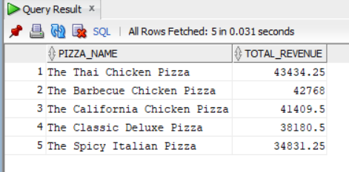

H. Bottom 5 Pizzas by Revenue
SELECT Top 5 pizza_name, SUM(total_price) AS Total_Revenue
FROM pizza_sales
GROUP BY pizza_nameORDER BY Total_Revenue ASC
Output

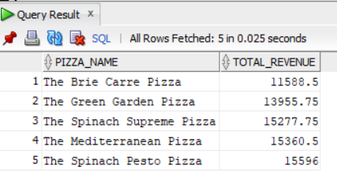
I. Top 5 Pizzas by Quantity
SELECT Top 5 pizza_name, SUM(quantity) AS Total_Pizza_Sold
FROM pizza_sales
GROUP BY pizza_name
ORDER BY Total_Pizza_Sold DESC
Output
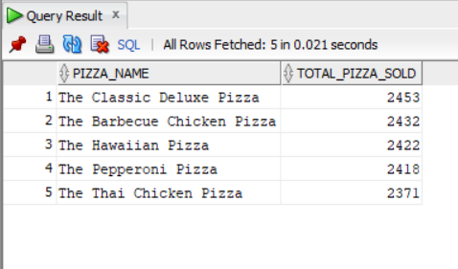

J. Bottom 5 Pizzas by Quantity
SELECT TOP 5 pizza_name, SUM(quantity) AS Total_Pizza_Sold
FROM pizza_sales
GROUP BY pizza_name
ORDER BY Total_Pizza_Sold ASC
Output
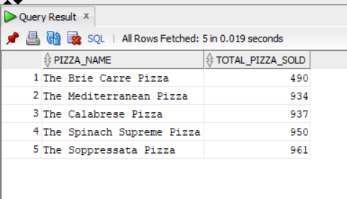

K. Top 5 Pizzas by Total Orders
SELECT Top 5 pizza_name, COUNT(DISTINCT order_id) AS Total_Orders
FROM pizza_sales
GROUP BY pizza_name
ORDER BY Total_Orders DESC

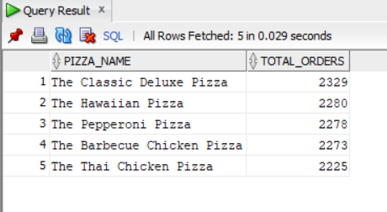
L. Borrom 5 Pizzas by Total Orders
SELECT Top 5 pizza_name, COUNT(DISTINCT order_id) AS Total_Orders
FROM pizza_sales
GROUP BY pizza_name
ORDER BY Total_Orders ASC
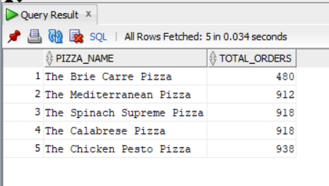

sNOTE
If you want to apply the pizza_category or pizza_size filters to the above queries you can use WHERE clause. Follow some of below examples
SELECT Top 5 pizza_name, COUNT(DISTINCT order_id) AS Total_Orders
FROM pizza_sales
WHERE pizza_category = 'Classic'
GROUP BY pizza_name ORDER BY Total_Orders ASC

